Question : 1
Write down the null hypothesis (H0) and alternative hypothesis (H1) for the following scenario: You believe that people spend more time on Instagram than on YouTube daily :

Null and Alternative Hypothesis :
“We believe that people spend more time on Instagram than on YouTube daily”

- Null Hypothesis (H₀):
People spend the same amount of time on Instagram and YouTube daily.
H₀: μInstagram ≤ μYouTube

- Alternative Hypothesis (H₁):
People spend more time on Instagram than on YouTube daily.
H₁: μInstagram > μYouTube
This is a one-tailed test.

Question : 2
Given the data: Group A (users shown a new Zomato home page) had an average order value of ₹350 from 30 users, and Group B (old home page) had an average order value of ₹320 from 30 users. Assume both groups have a standard deviation of ₹50. Calculate the p-value using a two-sample t-test (you may use Python, R, or an online calculator), and decide whether to accept or reject the null hypothesis at a 0.05 significance level.<br><br><em><strong>Hint:</strong> Use scipy.stats.ttest_ind in Python or any online t-test calculator if you are not comfortable with code : </em>

Group A (New Zomato Home Page):
- Mean = ₹350
- Standard Deviation = ₹50
- Sample Size = 30
Group B (Old Zomato Home Page):
- Mean = ₹320
- Standard Deviation = ₹50
- Sample Size = 30

Hypotheses :
H₀ (Null Hypothesis): There is no significant difference between the average order values of Group A and Group B.
H₁ (Alternative Hypothesis): There is a significant difference between the average order values of Group A and Group B.
This is a two-tailed test.

Calculate t-statistic :
t = (X₁ - X₂) / √[(s₁²/n₁) + (s₂²/n₂)]
t = (350 - 320) / √[(50²/30) + (50²/30)]
t = 30 / √[2500/30 + 2500/30]
t = 30 / √[83.33 + 83.33]
t = 30 / √166.66
t = 30 / 12.91
t = 2.324

Degrees of Freedom :
For two independent samples:
df = n₁ + n₂ - 2
df = 30 + 30 - 2
df = 58

P-value :
Using a two-tailed t-test with:
t = 2.324
df = 58
p-value = 0.024

Decision :
Significance level (α) = 0.05
0.024 < 0.05
we reject the null hypothesis (H₀).
from scipy.stats import ttest_ind_from_stats
t_stat, p_value =ttest_ind_from_stats(
mean1=350, std1=50, nobs1=30,
mean2=320, std2=50, nobs2=30
)
print(f"t-statistic:{t_stat}")
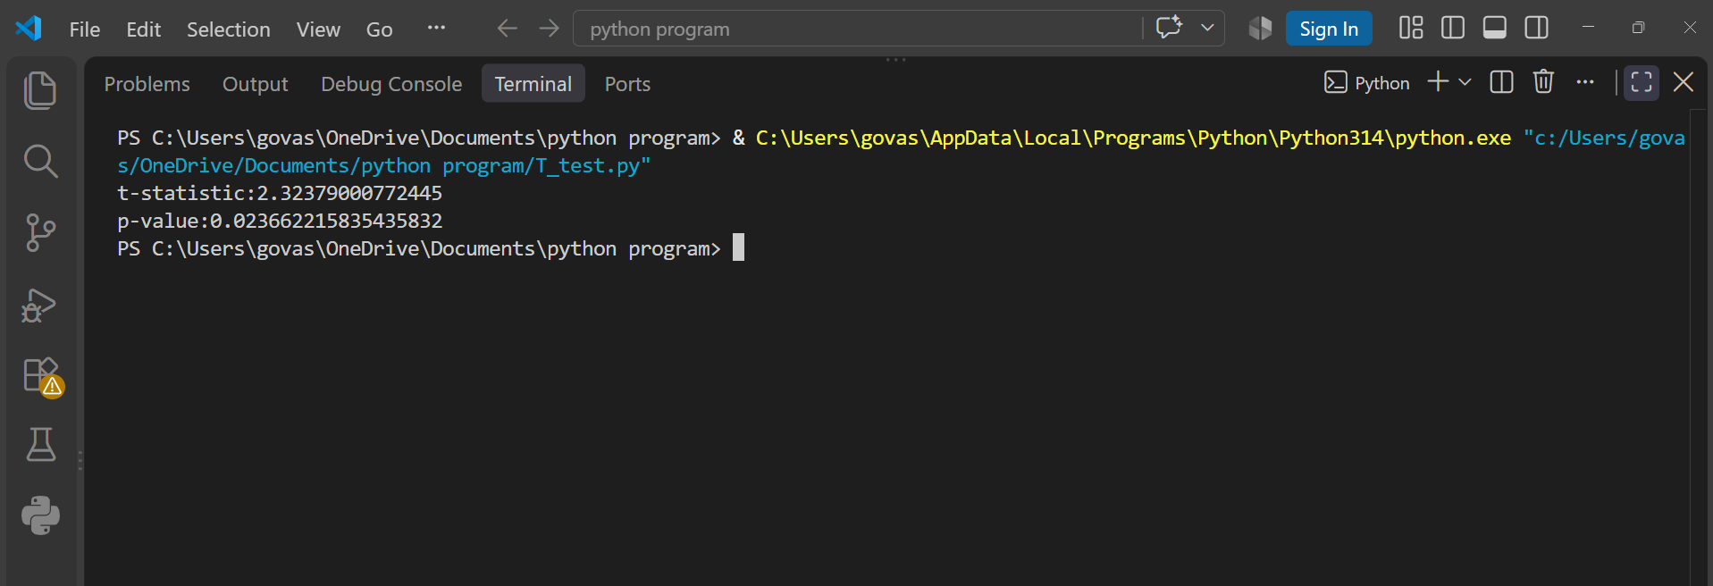
print(f"p-value:{p_value}")

Conclusion: There is statistically significant evidence that the new Zomato home page results in a different average order value. Since the new page has the higher mean (₹350 vs ₹320), the result supports the idea that the new page improves average order value.

Question : 3
Pick any feature from your favorite app (like the new dark mode in WhatsApp or a redesigned payment button in Paytm) and describe how you would set up an A/B test for it. Clearly state what your control and variant groups would be, what metric you would measure, and what your null and alternative hypotheses are :

Feature: New Dark Mode design in WhatsApp.
Control Group (A): Users continue using the existing/default WhatsApp interface.
Variant Group (B): Users receive the new Dark Mode design.

I would measure daily active usage time or user engagement, such as the average time users spend on WhatsApp per day.

Null Hypothesis (H₀): The new Dark Mode does not change average user engagement.
Alternative Hypothesis (H₁): The new Dark Mode increases average user engagement.

I would randomly divide users into the two groups, run the test for a fixed period, and compare the metric between the control and variant groups. If the p-value is below 0.05, I would reject H₀ and consider the new design statistically significant.

Question : 4
Suppose you run an A/B test for a new 'Add to Wishlist' button design on Flipkart. Out of 1000 users, 520 clicked the new button versus 480 who clicked the old button. Without doing detailed calculations, explain if this difference is likely to be significant or just due to chance. Briefly explain how the p-value helps you decide :

- New button clicks = 520
- Old button clicks = 480
- Total = 1000
520 − 480 = 40 users, or 4 percentage points.

Although the new button has more clicks, this difference is not necessarily statistically significant. With 1000 users, a difference of 40 could reasonably occur due to random chance.

- p-value < 0.05 → statistically significant → reject H₀
- p-value ≥ 0.05 → not statistically significant → fail to reject H₀
For these numbers, the p-value would be around 0.20, which is greater than 0.05.

Conclusion: The difference is likely due to chance rather than a statistically significant improvement. We would not reject the null hypothesis based on this result.

